Nut and washer sets from

HPC
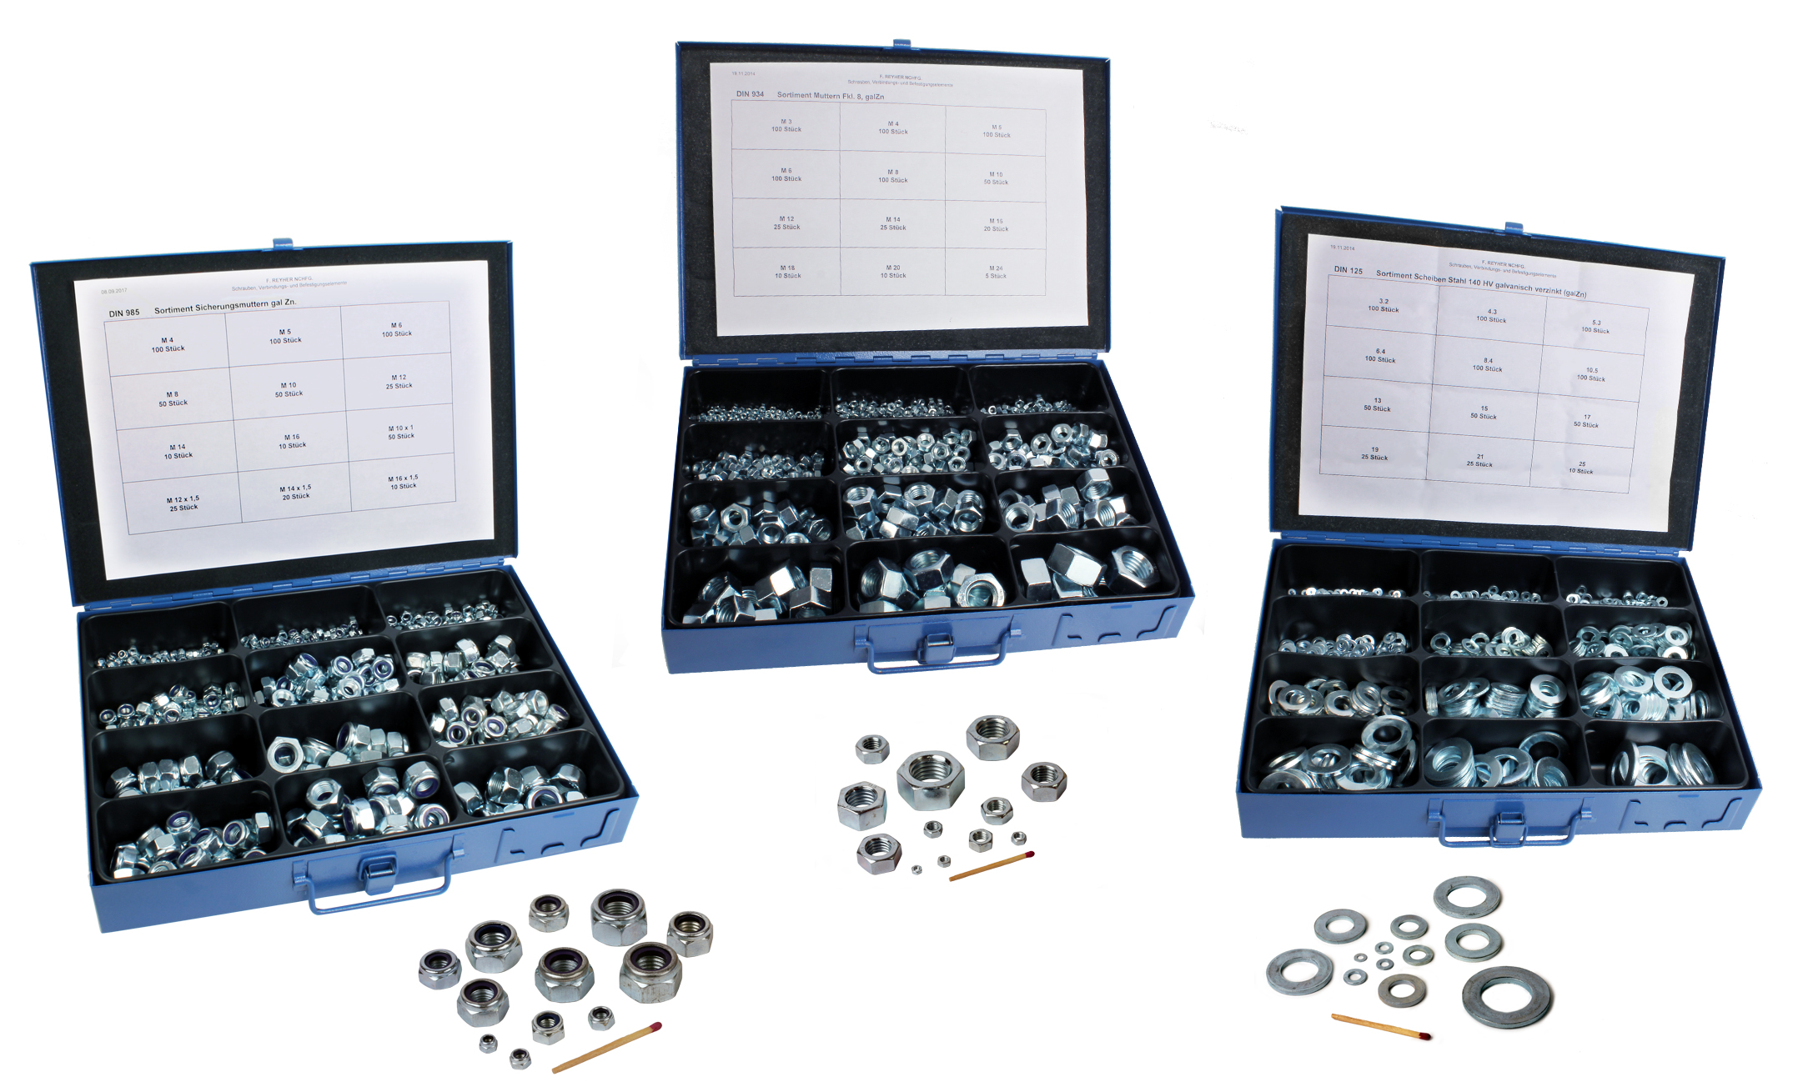

Engrenages HPC has added to its fixing range with new nut and washer sets. To meet the requirements of maintenance departments, 3 new box sets are available:

- A set of 550 steel DIN985 self-locking nuts in sizes from M4 to M16 (standard thread) and M10 to M16 (fine thread),
- A set of 670 galvanised steel DIN934 hexagonal nuts in sizes from M3 to M24 (standard thread)
- A set of 810 galvanised steel standard DIN125 washers in sizes from M3 to M24.

Packs containing individual nuts and washers are also available in both steel and stainless steel.

